**Working with ECS using fargate**

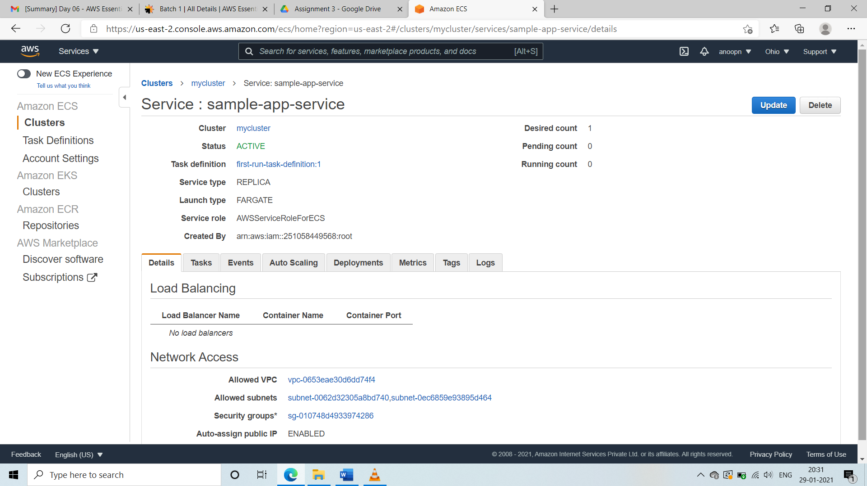

**SS1:** **Task 1:Create a cluster**

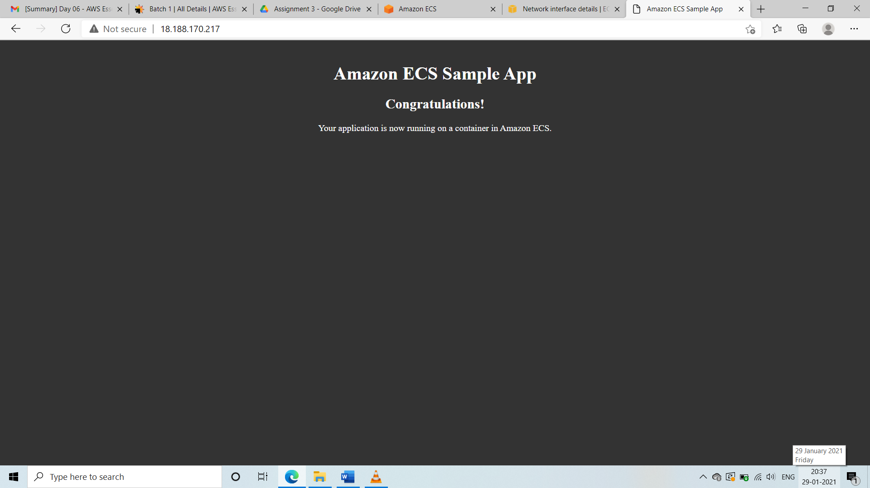

**SS2:Task 2:Deploy a sample application**

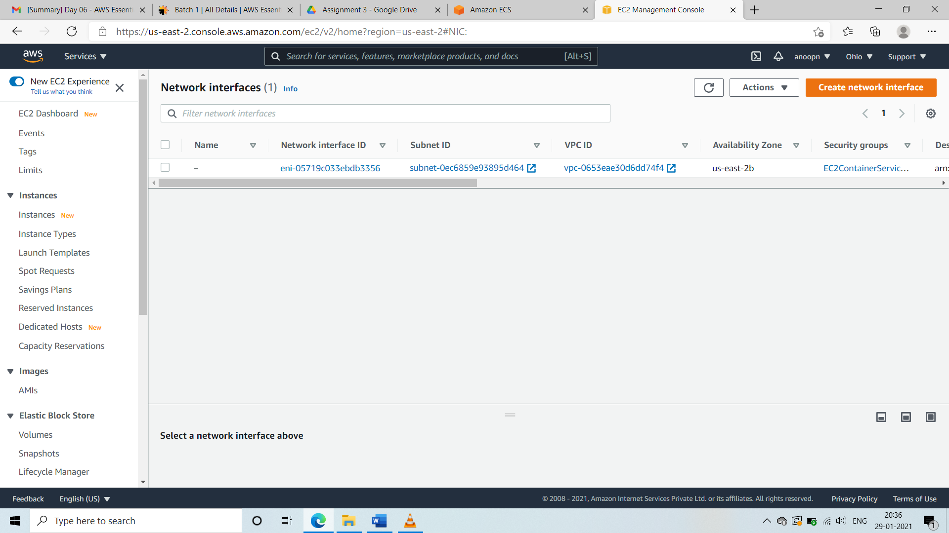

**SS3:Task 3:Show the ec2 instance created automatically**